**STUDENT ON-DUTY AND EVENT MANAGEMENT SYSTEM **

# MINI PROJECT

***Submitted by***

|  |  |
| --- | --- |
| **DARSHIKA. M** | **22BCS098** |
| **PRINCY DHANCIYA .N** | **22BCS078** |
| **MUGILAN.A** | **22BCS108** |

***in partial fulfilment for the award of the degree of***

**BACHELOR OF ENGINEERING**

***in***

**COMPUTER SCIENCE AND ENGINEERING**

# Dr. MAHALINGAM COLLEGE OF ENGINEERING AND TECHNOLOGY

**(An Autonomous Institution Affiliated to Anna University Chennai)**

**JUNE 2024**

**Dr. MAHALINGAM COLLEGE OF ENGINEERING AND TECHNOLOGY, POLLACHI -642 003**

**(An Autonomous Institution Affiliated to Anna University, Chennai - 600 025)**

**BONAFIDE CERTIFICATE**

Certified that this Mini project report titled **“STUDENT ON-DUTY AND EVENT MANAGEMENT SYSTEM”** is the bonafide work of

|  |  |
| --- | --- |
| **DARSHIKA.M** | **22BCS098** |
| **PRINCY DHANCIYA.N** | **22BCS078** |
| **MUGILAN.A** | **22BCS108** |

who carried out the mini project under my supervision.

|  |  |
| --- | --- |
| Ms. S.C. Lavanya  Assistant Professor(SS)  **SUPERVISOR**  Dept. of Computer Science and Engineering  Dr.Mahalingam College of Engineering and Technology, Pollachi- 642003 | Dr.G.Anupriya  Professor  **HEAD OF THE DEPARTMENT**  Dept. of Computer Science and Engineering  Dr.Mahalingam College of Engineering and Technology, Pollachi- 642003 |

Submitted for the Autonomous End Semester Mini Project Examination

held on _____________

# INTERNAL EXAMINER 1 INTERNAL EXAMINER 2

# ACKNOWLEDGEMENT

First and foremost, we wish to express our deep unfathomable feeling, gratitude to our institution and our department for providing us a chance to fulfill our long- cherished dreams of becoming Computer Science Engineers.

We express our sincere thanks to our honorable Secretary **Dr.C.Ramaswamy** for providing us with required amenities.

We wish to express our hearty thanks to **Dr. P.Govindasamy,** Principal of our college, for his constant motivation and continual encouragement regarding our project work.

We are grateful to **Dr. G.Anupriya,** Head of the Department, Computer Science and Engineering, for her direction delivered at all times required. We also thank her for her tireless and meticulous efforts in bringing out this project to its logical conclusion.

Our hearty thanks to our guide **Ms. S. C. Lavanya,** Assistant Professor(SS) for her constant support and guidance offered to us during the course of our project by being one among us and all the noble hearts that gave us immense encouragement towards the completion of our project.

We are deeply grateful to our mini project coordinators cum review panel members, **Dr.M.L.Valarmathi,** Professorand **Ms.S.C.Lavanya,** Assistant Professor(SS) for their constant guidance, patience, and support.

# STUDENT ON-DUTY AND EVENT MANAGEMENT SYSTEM

# ABSTRACT

The proposed event management system is a web-based platform designed for seamless approval of on-duty requests. This system will streamline the recording of student participation in various events across colleges, documenting achievements and contributions. The website aims to enhance efficiency by automating the approval process for on-duty requests and providing a comprehensive database to track student involvement. Through a user-friendly interface, colleges can manage event records, fostering a transparent and organized platform for tracking student achievements, ensuring a hub for event management and participant recognition.

This project focuses on a user-friendly website Through seamless web interfaces, organizers can streamline duty assignments, enhancing event coordination. The platform aims to provide a centralized hub for managing event logistics, participant records, and accolades, ensuring a comprehensive and organized approach to student engagement.

# TABLE OF CONTENTS

|  |  |  |
| --- | --- | --- |
| **CHAPTER NO** | **TITLE** | **PAGE NO** |
|  | Abstract | i |
|  | List of Abbreviations | iii |
|  | List of Figures | iv |
| **1** | **Introduction** | **1** |
|  |  |  |
| **2** | **Literature Survey** | **2** |
|  | 2.1 Web-based clinical management | 2 |
|  | 2.2 Electronic Records | 2 |
|  | 2.3 Communication | 2 |
|  | 2.4 Online appointment booking | 3 |
|  |  |  |
| **3** | **Problem Statement** | **3** |
|  |  |  |
| **4** | **Objective of the Project** | **4** |
|  |  |  |
| **5** | **Proposed System** | **5** |
|  | 5.1 Circuit Diagram / Block Diagram | 6 |
|  | 5.2 Module Description | 7 |
|  |  |  |
| **6** | **Hardware and Software details** | **8** |
|  | 6.1 Hardware Details | 8 |
|  | 6.2 Software Details | 8 |
|  |  |  |
| **7** | **Results and Discussions** | **9** |
| **8** | **Conclusion and Future Work** | **10** |
| **9** | **References** | **11** |
| **10** | **Publications/ Project Contest Proof** |  |
|  | Appendix A: Sample Code | A.1 |
|  | Appendix B : Screenshots | B.1 |

**LIST OF ABBREVIATION**

|  |  |  |
| --- | --- | --- |
| NIL |  |  |
|  |  |  |
|  |  |  |
|  |  |  |
|  |  |  |
|  |  |  |
|  |  |  |

**LIST OF FIGURES**

NIL

|  |  |
| --- | --- |
| The Student On Duty and Event Management System—a revolutionary web-based platform designed to streamline and enhance student participation and event coordination across colleges. Our system is tailored to provide a seamless experience for both students and organizers, offering innovative features to simplify on-duty requests and manage events with ease.  With our platform, students can easily submit on-duty requests and track their involvement in various events, ensuring transparency and accountability in their contributions. Organizers, on the other hand, gain access to powerful tools to efficiently manage event logistics, assign duties, and recognize student achievements. |  |
|  |  |
|  |  |
|  |  |
|  |  |
|  |  |
|  |  |
|  |  |
|  |  |
|  |  |

**INTRODUCTION**

**LITERATURE SURVEY**

**PROBLEM STATEMENT**

The Event Management System described in the literature survey report is a comprehensive web application developed using Java programming language. Unlike typical event display websites, this system offers advanced features such as event booking and recommendations for users. With a centralized database, all operations are securely stored and managed, ensuring efficient communication between event organizers and users.

Upon logging in, users are greeted with personalized event recommendations, facilitated by the Apache Mahout API. They can then proceed to view, book, and pay for events directly through the system. Additionally, users have the option to provide feedback, contributing to the system’s continuous improvement.

Event organizers undergo a registration process, with their details verified by administrators. Once authorized, organizers can publish event details and access booking information. Importantly, every transaction within the system is securely recorded in the database, providing a robust audit trail for accountability.

One of the system’s key advantages is its ability to accommodate multiple users simultaneously, making it a versatile tool for managing events and facilitating communication between organizers and attendees. Overall, the Event Management System represents a significant step forward in optimizing event organization and user experience within the digital landscape.

The Student On Duty and Event Management System aims to revolutionize the way colleges manage events and track student participation. Existing methods often suffer from fragmentation, limited accessibility, accountability issues, coordination complexity, and a lack of data insights. Our solution provides a centralized platform that streamlines event On-duties of students, making it easier for both students and admin to manage and participate in events.

It also facilitates to track the Certifications and status of the event participation, which is difficult for the admin to track. Additionally, the system’s robust database and analytics capabilities provide valuable insights into student engagement patterns and event effectiveness, empowering colleges to make data-driven decisions and create a more vibrant and engaged campus community.

**OBJECTIVE OF THE PROJECT**

The objectives of the student on-duty approval and tracking system are:

1. Efficient Approval Process: Develop a streamlined process for approving student on-duty requests, ensuring timely and accurate responses to student requests.

2. Transparent Tracking: Implement a transparent tracking system to monitor and record student on-duty assignments, providing visibility into duty schedules and assignments for both students and administrators.

3. Automated Notifications: Enable automated notifications to notify students of the status of their on-duty requests, as well as reminders for upcoming duty assignments, enhancing communication and accountability.

4. Database: Establish a database to securely store all on-duty requests, approvals, and assignments, facilitating easy access to historical data and generating reports for analysis.

5. User-Friendly Interface: Design an intuitive and user-friendly interface for students to submit on-duty requests and view their duty assignments, minimizing confusion and maximizing usability.

6. Administrative Oversight: Provide administrators with tools to efficiently manage and oversee the on-duty approval process, including the ability to review, approve, or reject requests, as well as to assign duties as needed.

7. Enhanced Accountability: Enhance accountability by recording attendance and performance during on-duty assignments, allowing for evaluation and recognition of student contributions.

8. Optimized Resource Allocation: Optimize resource allocation by providing insights into duty demand and availability, allowing administrators to allocate duties efficiently and effectively.

**PROPOSED SYSTEM**

The proposed Student On Duty and Event Management System report outlines a comprehensive solution designed to streamline event coordination and student participation tracking in colleges. This system addresses existing challenges such as fragmentation, limited accessibility, accountability issues, coordination complexity, and a lack of data insights prevalent in traditional methods.

The report provides an overview of the system’s objectives, including:

1. Streamlining Event Coordination: Developing a centralized platform to simplify event planning, organization, and execution.

2. Enhancing Student Participation Tracking: Implementing mechanisms for accurately tracking student involvement in events.

3. Improving Accessibility for Students: Designing user-friendly interfaces for students to access event information and booking options easily.

4. Facilitating Organizational Efficiency: Empowering event organizers with tools to efficiently manage event details and communicate with participants.

5. Ensuring Accountability and Recognition: Implementing mechanisms to ensure accountability for student attendance and contributions, as well as systems for recognizing and rewarding student efforts.

6. Providing Valuable Data Insights: Establishing a comprehensive database infrastructure for capturing and analyzing event data to gain valuable insights.

7. Fostering a More Engaged Campus Community: Cultivating a vibrant campus community through well-organized and engaging events that enhance the overall college experience.

Overall, the proposed Student On Duty and Event Management System represents a significant advancement in optimizing event management processes and fostering a more vibrant and engaged campus community in colleges.

**CIRCUIT/BLOCK DIAGRAM**

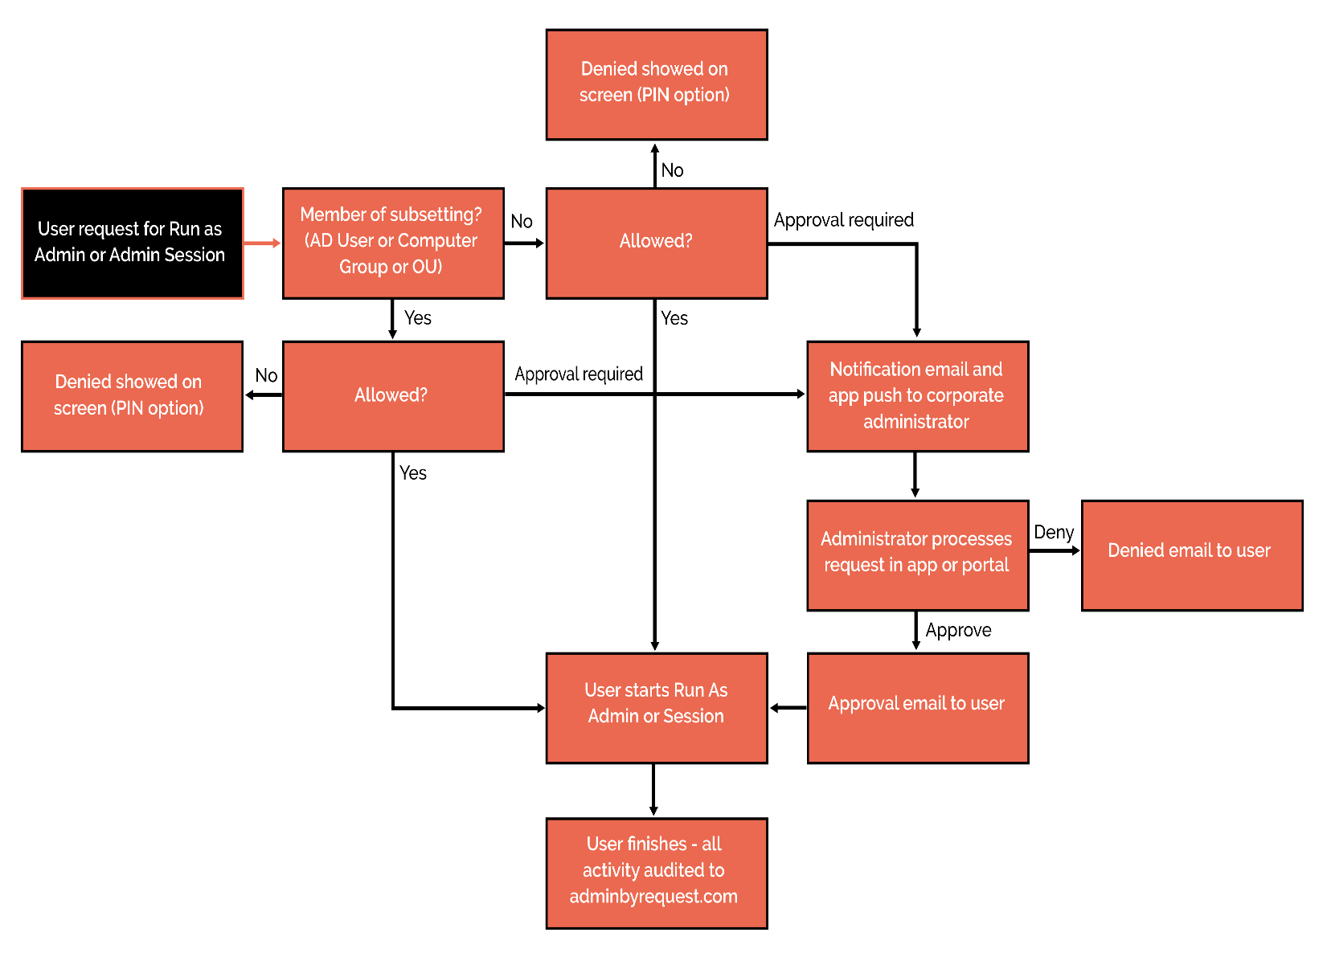 **B1.**

**MODULE DESCRIPTION**

The Student On Duty and Event Management System comprises several modules, each serving a specific purpose within the overall system. Here are the module descriptions:

1. User Authentication and Management Module: This module handles user authentication, registration, and management functionalities. It allows users (both students and admins) to create accounts, log in securely, and manage their profiles.
2. Event Management Module: This module is responsible for managing the on-duty for event.
3. Student Participation Tracking Module: This module tracks student participation in events and on-duty assignments. It records certification ,

Geo-tagged photos and participation status providing admin with insights into student engagement.

1. On-Duty Approval Module: This module handles the approval process for student on-duty requests. It allows students to submit on-duty requests, which are then reviewed and approved by designated authorities (e.g., administrators or supervisors).
2. Recognition Module: This module facilitates feedback collection from participants. It allows students to provide certificates on their event and allows organizers to recognize outstanding contributions or achievements.
3. Notification Module: This module sends automated notifications to users regarding event updates, on-duty approvals, reminders, and other relevant information. It ensures timely communication and keeps users informed about important events and tasks.
4. Reporting and Analytics Module: This module generates reports and analytics based on data collected from various modules. Reports are generated in an Excel sheet.

Each module works seamlessly together to create a cohesive and efficient system for managing events and student participation within colleges.

**SOFTWARE DETAILS**

Visual Studio Code

PHP

XAMPP

HTML – Hyper text Markup Language

CSS – Cascading Style Sheets

JavaScript

MySQL

Notepad

MySQL Workbench

**RESULTS AND DISCUSSION**

The evaluation of the Student On Duty and Event Management System revealed commendable performance across key metrics. The system demonstrated reliability, scalability, and satisfactory speed, ensuring smooth operation under various conditions. User feedback indicated overall satisfaction with the system’s interface and functionality, though some minor accessibility issues were noted.

Practically, the system significantly improved on duty approval system within colleges. Organizers reported enhanced efficiency and coordination attributed to the system’s centralized database and intuitive tools. It made On-duty interaction easier.

Administrators appreciated the system’s oversight and accountability capabilities, enabling better tracking of student participation and event management activities. Data insights from the system aided decision-making, and resource allocation. Compared to traditional methods, the system offered superior efficiency, accuracy, and user satisfaction, highlighting its effectiveness as an On-duty approval system solution. Recommendations for future enhancements include refining the user interface and expanding mobile accessibility.

**CONCLUSION & FUTURE WORK**

The Student On Duty and Event Management System has proven to be a useful On-duty approval system. Through its reliable performance, user-friendly interface, and robust features, the system has significantly improved efficiency, coordination, and engagement over student’s event participations. Data insights have provided valuable inputs for informed decision-making.

Moving forward, there are several avenues for further enhancement and development of the system. Future work may include:

Enhanced Accessibility: Continuously refining the user interface to improve accessibility and accommodate diverse user preferences, including the development of mobile applications for on-the-go access.

Advanced Analytics: Incorporating advanced analytics capabilities to derive deeper insights from event data, such as predictive modeling for event attendance and engagement trends.

By prioritizing these areas for future work, the Student On Duty and Event Management System can continue to evolve and adapt to meet the changing needs of colleges and their communities, ultimately fostering a more vibrant and engaged campus environment.

**REFERENCES**

* + 1. **Seelapareddy, Harsha Vardhan, "Event Management System" (2023). All Capstone Projects. 675.**
    2. **Anjali Rana, Employee leave management system.**
    3. **An Introduction to Web Development and Programming” by Michael Mendez in 2014.**
    4. **https://workspace.google.com/intl/en_in/lp/sites/**
    5. **https://codedamn.com/news/php/complete-guide-to-web-development-with-php**
    6. **https://github.com/FrontendMasters**

**APPENDIX A: SAMPLE CODE**

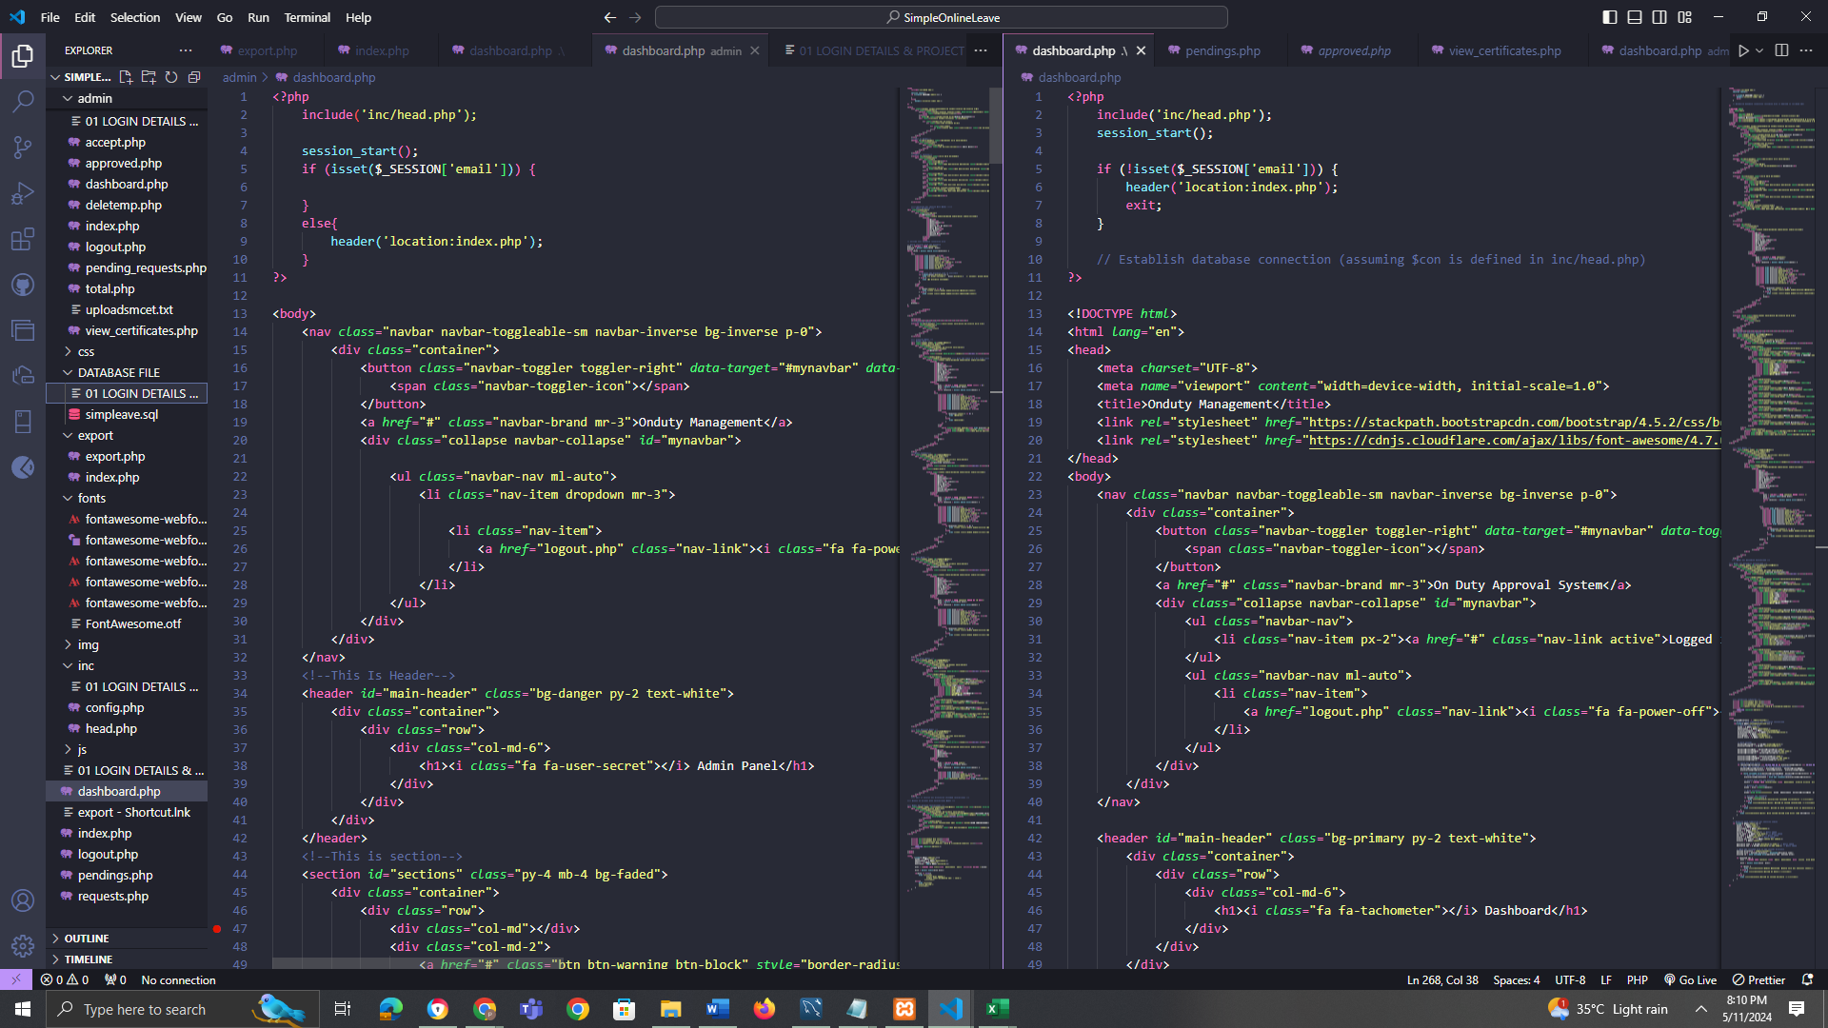

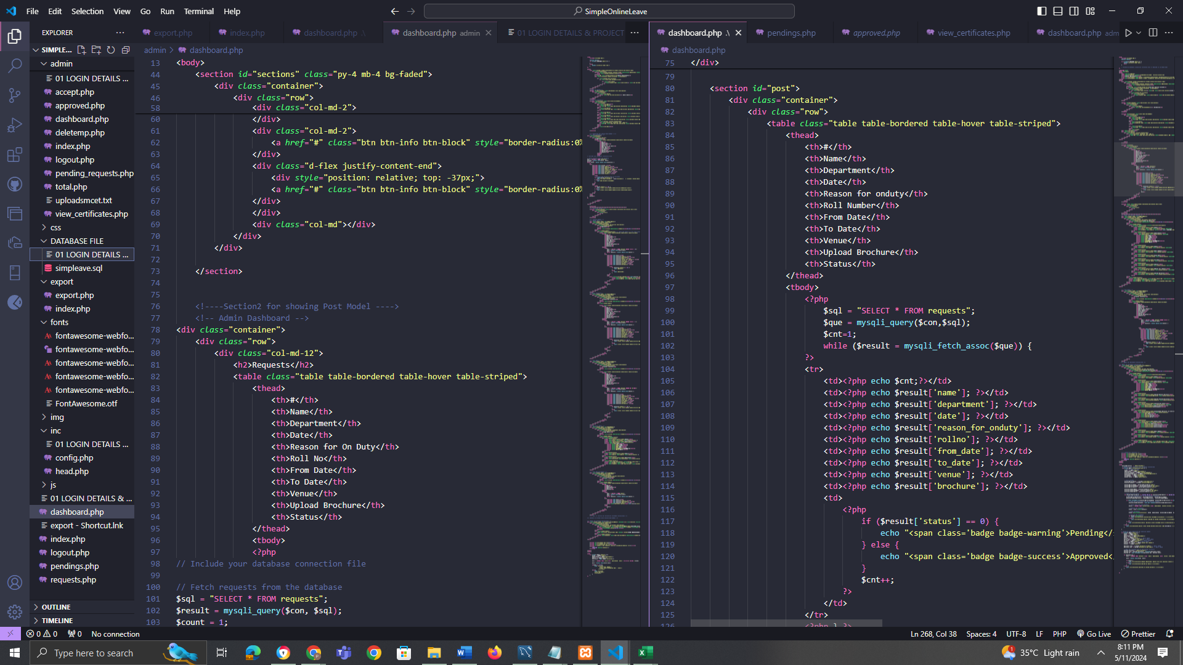

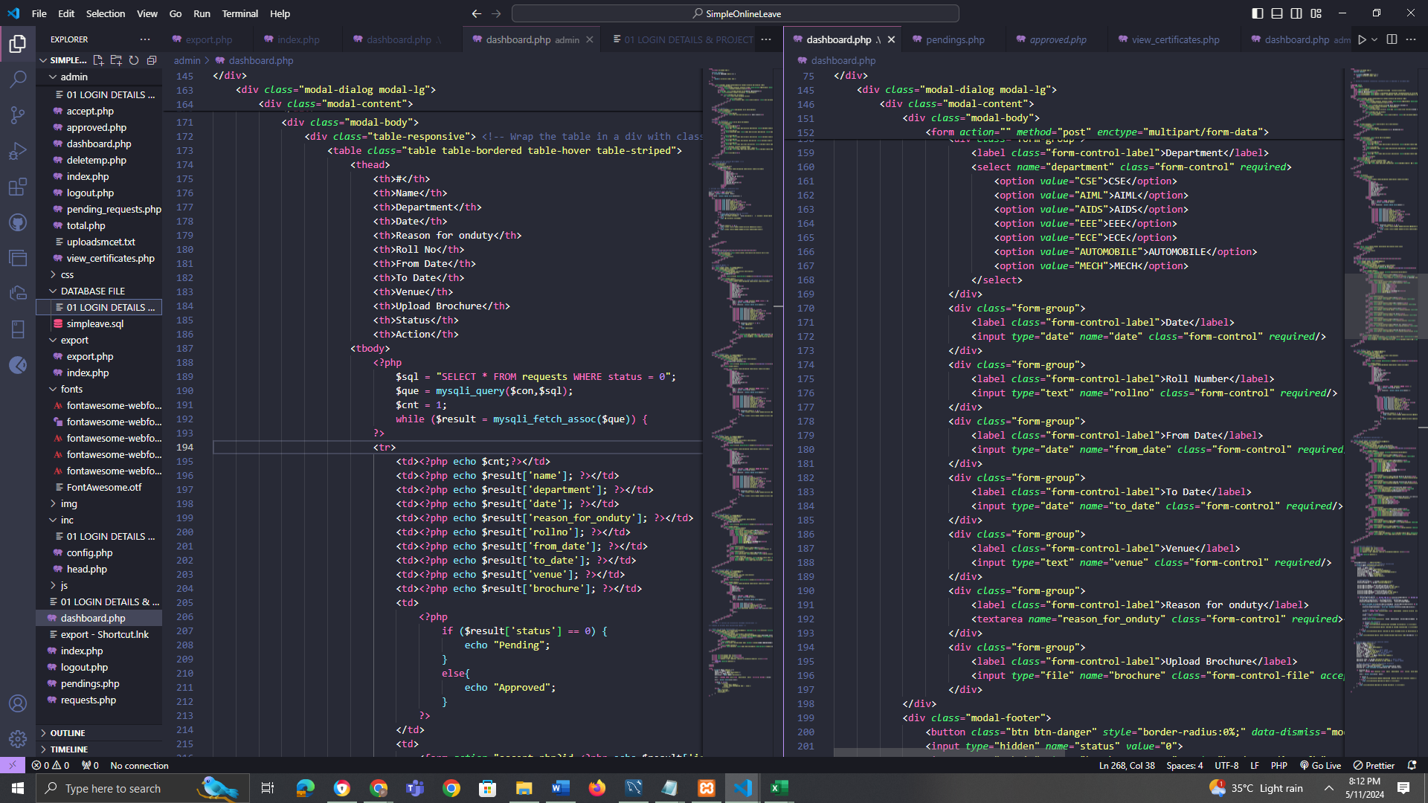

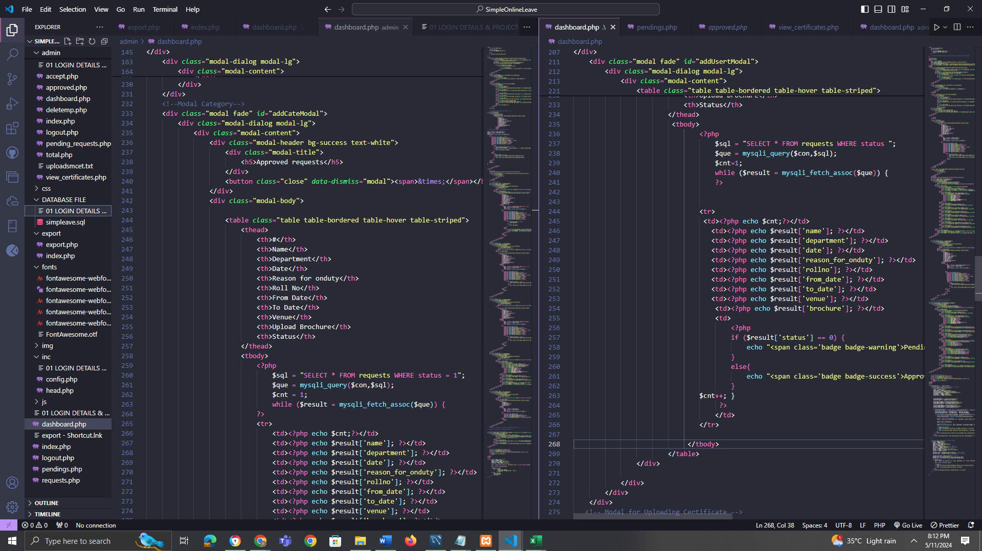

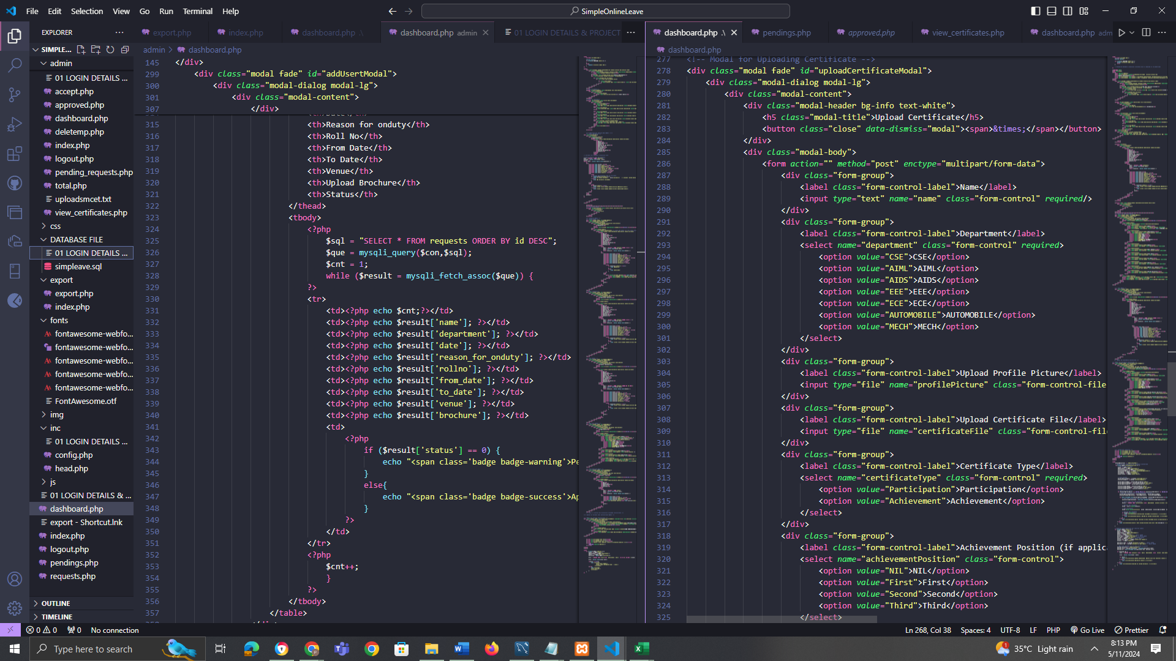

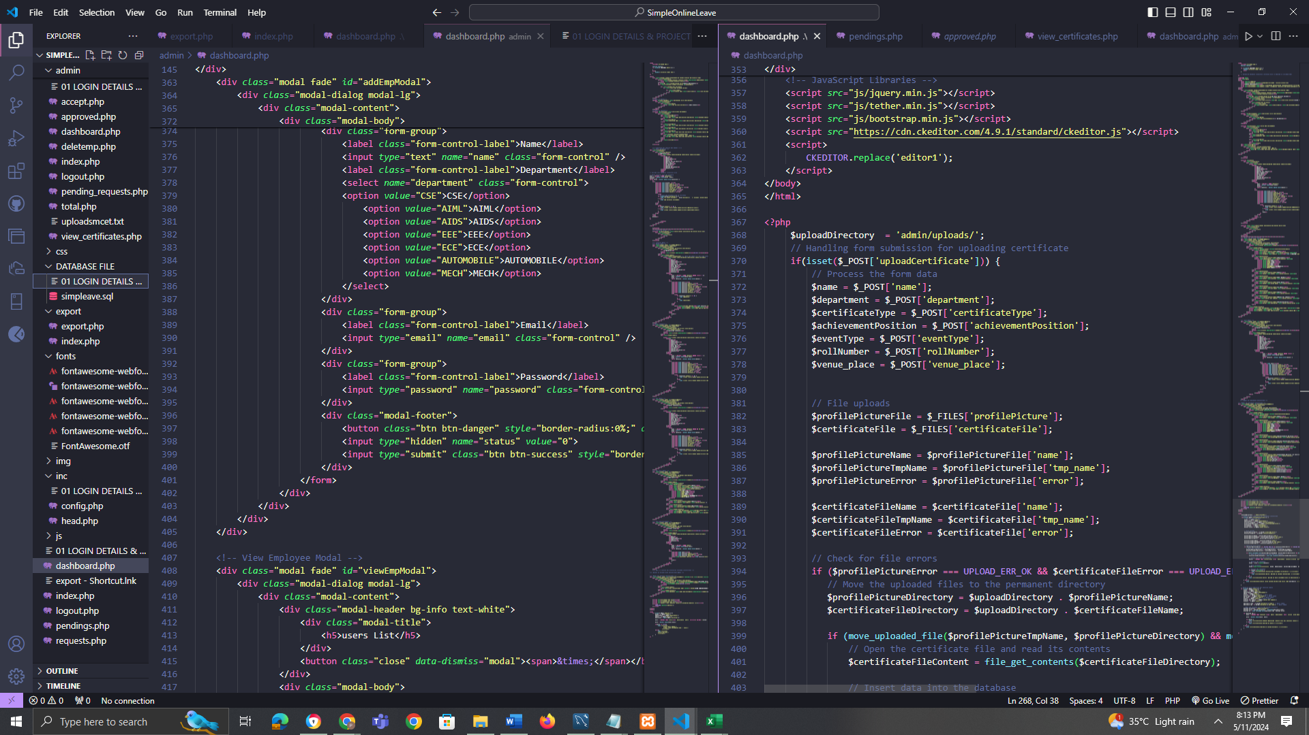

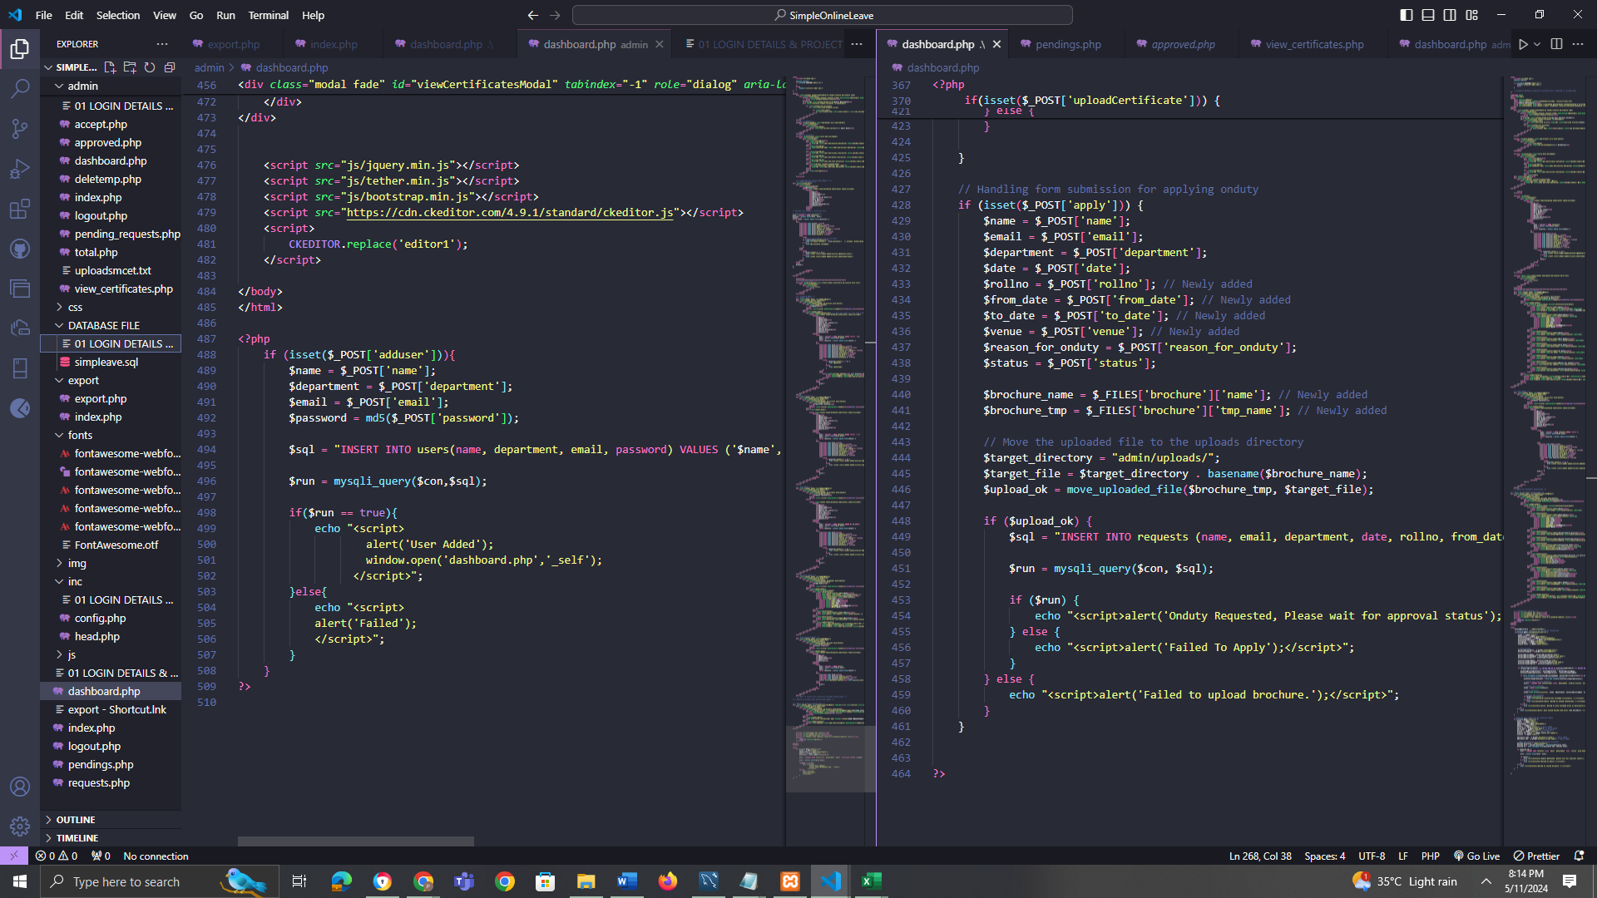

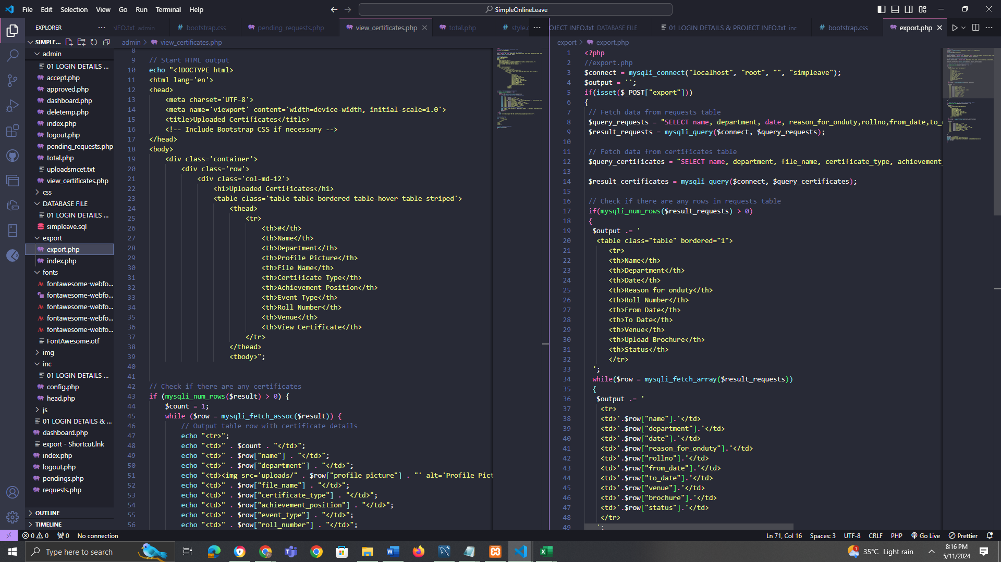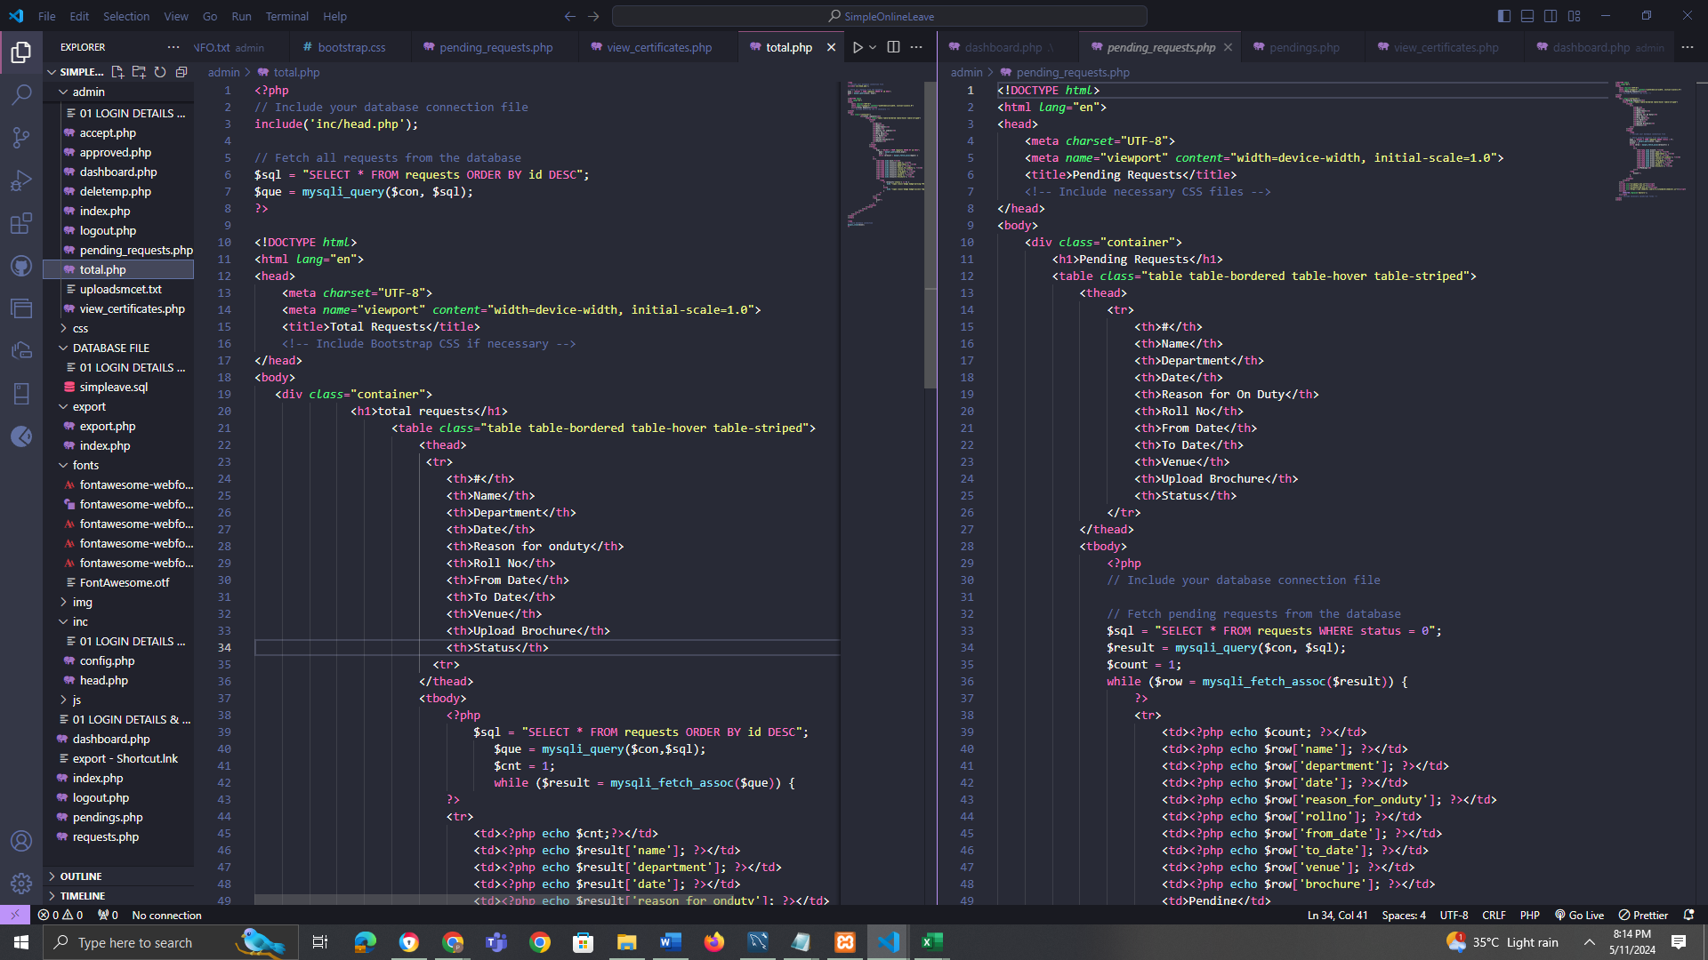

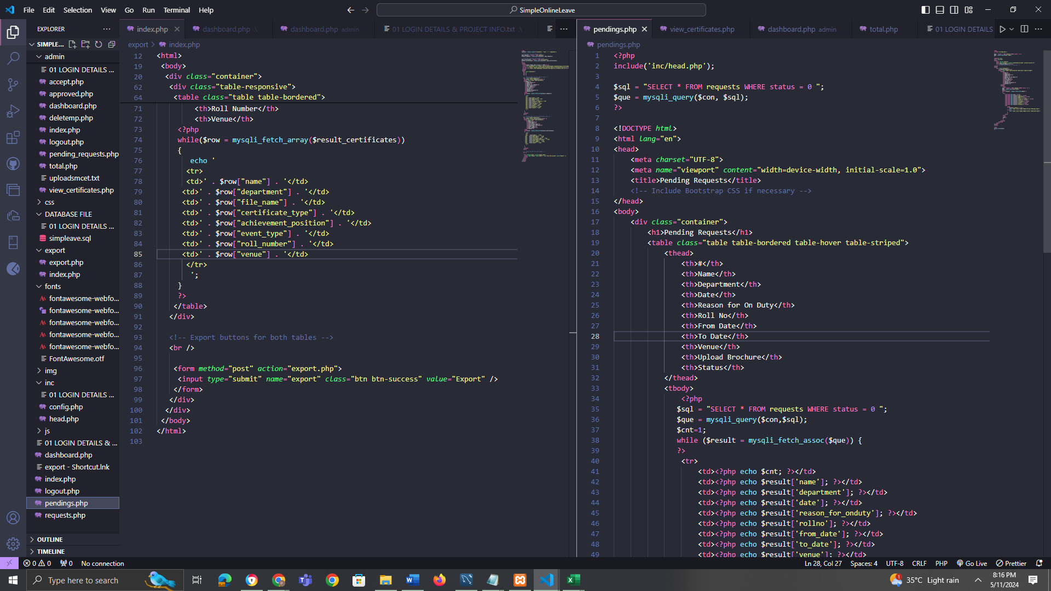

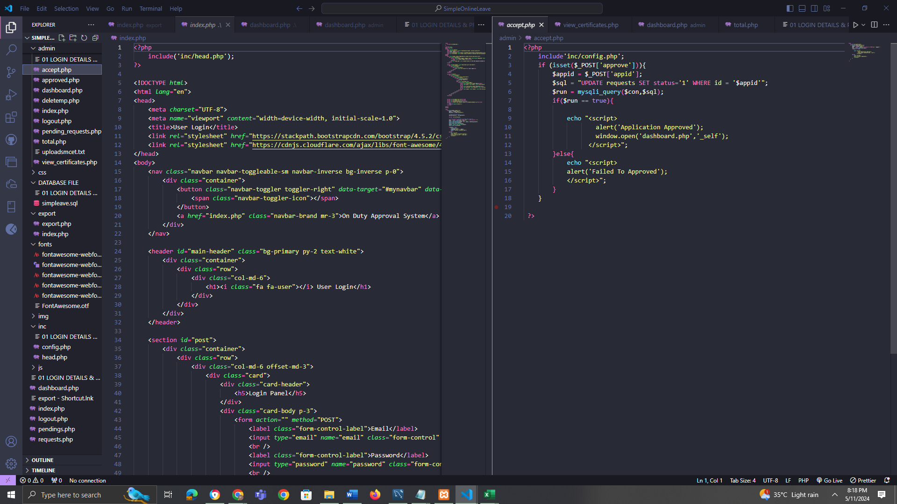

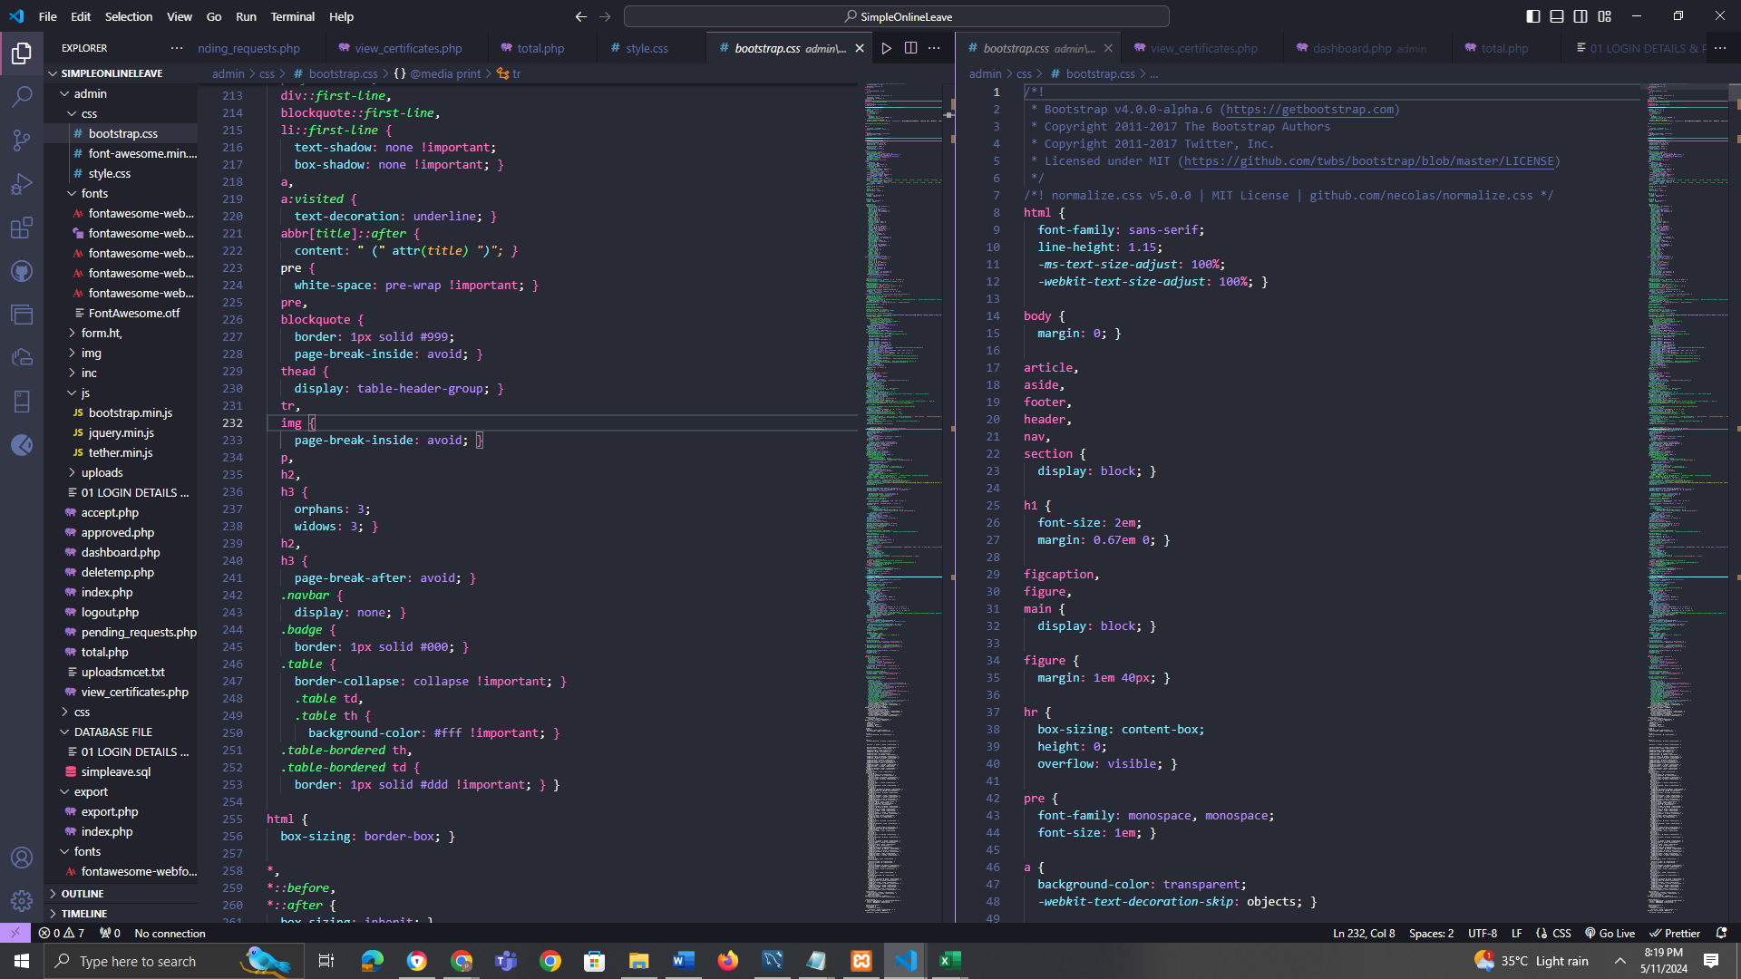

**APPENDIX B : SCREENSHOTS**

